- First check the AIX OS level and version before proceeding for AIX TL Update on aix server. Run oslevel -s command as per showing below image. Then proceed for AIX TL update. Run #smitty update_all command as per below snap shot.
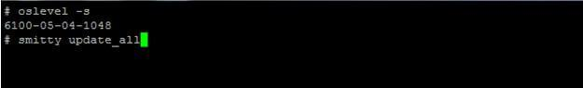AIX OS Level
- Now you will need to edit AIX TL package path or if you are already on the path then just enter the {.} dot and enter.
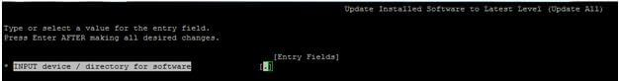Update Install Software
- After that you will need to fill all Entry Fields as per below snap shot.
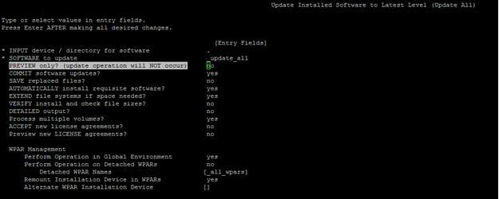AIX Update Install
- Most important is that do not select “Yes” option in “COMMIT Software updates”.You have to select “No” Option as per below output. Also Accept the new license agreement as “Yes”.
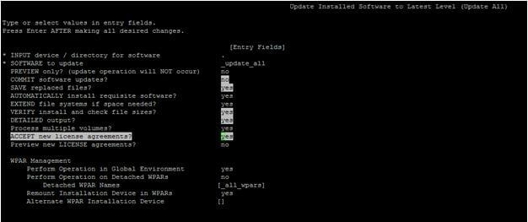AIX Update All
- This is the window you can see below “ARE YOU SURE ?” for proceed to update the AIX TL on aix server.
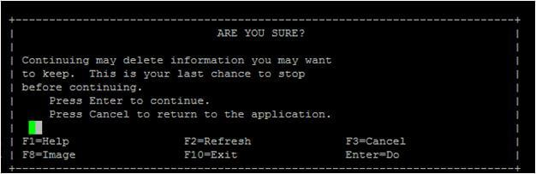AIX OS Info
- Now AIX TL update will start as per below screen shot.
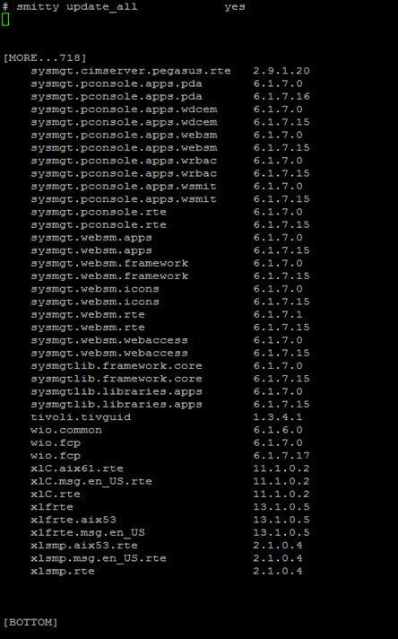Smitty Update_all
- AIX TL will be updated Successfully on aix server as you see in below screen shot. If Command shows Failed output then your AIX TL is not updated on server.
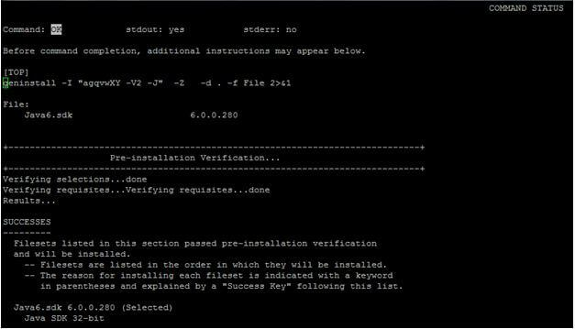AIX TL Updated

oslevel -s
7100-02-03-1334

oslevel -sq
Known Service Packs
-------------------
7100-02-03-1334
7100-02-02-1316
7100-02-01-1245
7100-02-00-0000
7100-01-08-1334
7100-01-07-1316
7100-01-06-1241
7100-01-05-1228
7100-01-04-1216
7100-01-03-1207
7100-01-02-1150
7100-01-01-1141
7100-00-10-1334
7100-00-09-1316
7100-00-08-1241
7100-00-07-1228
7100-00-06-1216
7100-00-05-1207
7100-00-04-1140
7100-00-03-1115
7100-00-02-1041
7100-00-01-1037

oslevel -r
7100-02

oslevel -rq
Known Recommended Maintenance Levels
------------------------------------
7100-02
7100-01
7100-00

#lppchk -v
#oslevel -rl 7100-02
#instfix -i | grep AIX
All filesets for 7.1.0.0_AIX_ML were found.
All filesets for 7100-00_AIX_ML were found.
All filesets for 7100-01_AIX_ML were found.
All filesets for 7100-02_AIX_ML were found.

#lslpp -h bos.mp64
Fileset Level Action Status Date Time
----------------------------------------------------------------------------
Path: /usr/lib/objrepos
bos.mp64
7.1.1.15 COMMIT COMPLETE 11/12/13 17:31:14
7.1.1.17 COMMIT COMPLETE 11/18/13 12:07:26
7.1.2.16 COMMIT COMPLETE 11/18/13 19:13:12

Path: /etc/objrepos
bos.mp64
7.1.1.15 COMMIT COMPLETE 11/12/13 17:31:17
7.1.1.17 COMMIT COMPLETE 11/18/13 12:07:26
7.1.2.16 COMMIT COMPLETE 11/18/13 19:13:12

#instfix -i |grep -i ML
All filesets for 7.1.0.0_AIX_ML were found.
All filesets for 7100-00_AIX_ML were found.
All filesets for 7100-01_AIX_ML were found.
All filesets for 7100-02_AIX_ML were found
.
#instfix -i |grep -i SP
All filesets for 71-00-011037_SP were found.
All filesets for 71-00-021041_SP were found.
All filesets for 71-00-031115_SP were found.
All filesets for 71-01-011141_SP were found.
All filesets for 71-00-041140_SP were found.
All filesets for 71-01-021150_SP were found.
All filesets for 71-01-031207_SP were found.
All filesets for 71-00-051207_SP were found.
All filesets for 71-01-041216_SP were found.
All filesets for 71-00-061216_SP were found.
All filesets for 71-01-051228_SP were found.
All filesets for 71-00-071228_SP were found.
All filesets for 71-00-081241_SP were found.
All filesets for 71-01-061241_SP were found.
All filesets for 71-02-011245_SP were found.
All filesets for 71-02-021316_SP were found.
All filesets for 71-00-091316_SP were found.
All filesets for 71-01-071316_SP were found.
All filesets for 71-00-101334_SP were found.
All filesets for 71-01-081334_SP were found.
All filesets for 71-02-031334_SP were found.

Pre-installation Verification...
+-----------------------------------------------------------------------------+
Verifying selections...done
Verifying requisites...done
Results...

WARNINGS
--------
Problems described in this section are not likely to be the source of any
immediate or serious failures, but further actions may be necessary or
desired.

Conflicting Versions of Filesets
--------------------------------
The following filesets are conflicting versions of filesets for which there
are multiple versions on the installation media. Since a specific version
was not selected, the newest installable version has been selected.

infocenter.man.EN_US.libs 7.1.2.0 # AIX manual libs - U.S. English
infocenter.man.EN_US.files 7.1.2.0 # AIX manual files - U.S. English
infocenter.man.EN_US.commands 7.1.2.0 # AIX manual commands - U.S. E...

Superseded Fileset Updates
--------------------------
Fileset updates listed in this section will not be installed. Newer
updates which supersede (replace) these were selected instead (either by
you or automatically by the installation program). Make sure that the
superseding updates listed passed pre-installation verification.

bos.rte.install 7.1.2.1 (Superseded by 7.1.2.16)

<< End of Warning Section >>

SUCCESSES
---------
Filesets listed in this section passed pre-installation verification
and will be installed.

Mandatory Fileset Updates
-------------------------
(being installed automatically due to their importance)
bos.rte.install 7.1.2.16 # LPP Install Commands

<< End of Success Section >>

+-----------------------------------------------------------------------------+
BUILDDATE Verification ...
+-----------------------------------------------------------------------------+
Verifying build dates...done
FILESET STATISTICS
------------------
719 Selected to be installed, of which:
1 Passed pre-installation verification
1 Replaced by superseding updates
717 Deferred (see *NOTE below)
----
1 Total to be installed

+-----------------------------------------------------------------------------+
Summaries:
+-----------------------------------------------------------------------------+

Pre-installation Failure/Warning Summary
----------------------------------------
Name Level Pre-installation Failure/Warning
-------------------------------------------------------------------------------
bos.rte.install 7.1.2.1 To be superseded by
wio.fcp 7.1.2.1 To be superseded by 7.1.2.15
sysmgtlib.libraries.apps 7.1.2.0 To be superseded by 7.1.2.15
sysmgtlib.framework.core 7.1.2.0 To be superseded by 7.1.2.15
sysmgt.pconsole.rte 7.1.2.0 To be superseded by 7.1.2.15
sysmgt.pconsole.apps.wsmi 7.1.2.0 To be superseded by 7.1.2.15
sysmgt.pconsole.apps.wrba 7.1.2.0 To be superseded by 7.1.2.15
sysmgt.pconsole.apps.wdce 7.1.2.0 To be superseded by 7.1.2.15
.
.
.
.
.
bos.rte.install 7.1.2.1 Already superseded by 7.1.2.16

1800-035 Exit status (142) returned by command.
(Command process used stdout and stderr file
descriptors connected to SMIT via pipes.)

To reject the applied software:
#installp -r

To commit the <package>:
#installp -c -f <package>

To cleanup an incomplete installation:
#installp -C

To check the <package>:
#lppchk -c <package> Verifies that the / (root), /usr and /usr/share parts of the system are valid with each other: #lppchk -v

To install the file set associated with fix IX9999 from rmt0:
#instfix -k IX9999 -d /dev/rmt0.1

To verify fix IY6969 installed:
#instfix -ik IY6969

How to display missing filesets from service pack:
#instfix -icqv | grep ':-:'

To verify if you have all packages installed for the current ML and why after upgrade you cannot see the newer version:
# instfix -i |grep ML
All filesets for 6100-00_AIX_ML were found.
All filesets for 6100-01_AIX_ML were found.
All filesets for 6100-02_AIX_ML were found.
All filesets for 6100-03_AIX_ML were found.
All filesets for 6100-04_AIX_ML were found.
All filesets for 6100-05_AIX_ML were found.
All filesets for 6100-06_AIX_ML were found.
All filesets for 6.1.0.0_AIX_ML were found.
Not all filesets for 6100-07_AIX_ML were found.

# oslevel -s
6100-06-05-1115

